**SANJAY RAJU.J**

**SIVAMEENAL.S.P**

**RAMYA.A**



Certificate

This is to certify that the topic entitled- *Computer Science Project on “Math Megamix”* **i**s here with work done by

**J.SanjayRaju, S.P.Sivameenal, R.Ramya** of class **XII-R** in the computer science lab during the academic year 2015-16 under investigatory project towards CBSE BOARD examination, is a bonafied project work carried out by us in the stream of c++. This work has not been previously forwarded for any other purpose.

Internal External

Teacher’s sign Teacher’s sign

1

ACKNOWLEDGEMENT

We express our deep sense of gratitude to Mrs.Mary shanthi, Principal, Blossom Public School, Thanjavur, for her invaluable advice and guidance during our work.

We are grateful to Mrs.Shanmugapriya and Mrs.Anita sagaya mary, our computer faculty members, for their constant inspiration and suggestions provided for us during the project work.

We immensely thank all our teachers for their support rendered throughout our project. We are deeply indebted to our dear parents, friends and classmates, for their love and encouragement.

INDEX

* CERTIFICATE
* ACKNOWLEDGEMENT
* INTRODUCTION TO C++
* INTRODUCTION TO THE PROJECT
* ABSTRACT
* HARDWARE AND SOFTWARE REQUIREMENTS
* HEADER FILES AND THEIR USES
* SOURCE CODE
* OUTPUT
* CONCLUSION
* BIBLIOGRAPHY

INTRODUCTION TO C++

C++ is a statically typed, compiled, general-purpose, case-sensitive, free-form programming language that supports procedural, object-oriented, and generic programming.

C++ is regarded as a **middle-level** language, as it comprises a combination of both high-level and low-level language features.

C++ was developed by Bjarne Stroustrup starting in 1979 at Bell Labs in Murray Hill, New Jersey, as an enhancement to the C language and originally named C with Classes but later it was renamed C++ in 1983.

C++ is a superset of C, and that virtually any legal C program is a legal C++ program.

**Note:** A programming language is said to use static typing when type checking is performed during compile-time as opposed to run-time.

## Object-Oriented Programming

C++ fully supports object-oriented programming, including the four pillars of object-oriented development:

* Encapsulation
* Data hiding
* Inheritance
* Polymorphism

## Standard Libraries

Standard C++ consists of three important parts:

* The core language giving all the building blocks including variables, data types and literals, etc.
* The C++ Standard Library giving a rich set of functions manipulating files strings, etc.
* The Standard Template Library (STL) giving a rich set of methods manipulating data structures, etc.

INTRODUCTION TO THE PROJECT

Maths training is essential for children to florish effectively in the newly forming technological world of tomorrow.

It is now time for us to rethink our approach to maths learning.

Here is a brain teasers created by us to include every possible type of mathematical recreation involving elementary algebra and entertainment thinking. It would always stimulate critical

thinking and logical reasoning. It would guarantee for hours of fun and relation. We have designed this to develop some aspect of a person’s inborn potential to think creatively.

In the real world, math is about solving unsolved problems, analyzing unfamiliar situations, devising new mathematical systems and tools, exploring unknown landscapes and more — all the while reasoning with clear, rigorous logic. Students of math must ask their own questions and search for their own directions. These skills are essential outside math, but I believe that math research is a good way to train them. With proper guidance, [students can potentially discover something truly original](http://herngyi.weebly.com/1/post/2013/03/amateur-math-research.html).

This project proposes to overcome various difficulties in maths and to be investigated by all students. We have tried to categorize this project suitable for all level of people.

Nowadays, most of the people are using calculators for even small calculations like addition , subtraction , multiplication and division.

This program has developed to test your skills by doing simple calculations. It will help you to develop your mind ability. This program is like an interesting game. So, you can play any number of times .You will have your own id number to know your results later on, and to modify your details like name and age. User has to request the administrator through mail, to modify their details.

When you do this test, your time taken for each question will be displayed to you after the completion. Your total time taken will be recorded.

We have three levels of test i.e.

Level 1-easy (kids): consists of single digit mathematical

operations.

Level 2-medium (students): consists of double digit

numerical calculations.

Level 3-hard (all): consists of three digits statistical

Progressions.

All levels consist of 5 questions each.

Abstract

This program is designed to test the math’s skill of the user.

It allows you to take up the test and creates ID and stores it in a file. The users will have to enter their required details.

Main features of the administrator:

When you are admin

1. It allows you to view the student’s list.
2. It allows you to search for a student’s record.
3. It allows you to modify a student’s record.
4. It allows you to delete a student’s record.

Main features of the user:

1. It allows you to view the student’s list.
2. It allows you to search for a student record.

HARDWARE AND Software REQUIREMENTS

**Hardware Required**

* **Printer, to print the required documents of the project**
* **Compact Drive**
* **Processor : Pentium III**
* **Ram : 64 MB**
* **Hard disk : 20 Gb.**
* **software Required**
* **Operating system : Windows XP or Higher**
* **Turbo C++, for execution of program and**
* **Ms word, for presentation of output**

Header files and their uses

* iostream.h-for input and output stream
* fstream.h-for handling files
* conio.h-for input and output operations
* iomanip.h-for declaring several iostream manipulators that take an argument
* stdio.h-for standard input and output operations
* string.h-for handling set of characters
* stdlib.h-for library functions
* dos.h-for handling interrupts, producing sound, date and time functions etc.
* time.h-to manipulate date and time information

CLASSES AND THEIR PURPOSE

An object class is a component of Active Directory schema which defines the “type” for an object or in other words it defines the set of mandatory and optional attributes an object can have.

There are 3 types of object classes in AD

**Abstract:** This class is a mere template used to derive a new object the new class can be of any object class type. One abstract class can be a subclass of another abstract class only.

**Structural:** The objects of the structural class are usually those that form the logical framework of AD. It can be a subclass of abstract or structural class.

**Auxiliary:** It is included in the definition of structural, abstract or auxiliary classes, for which they must Contain, system must Contain, may Contain and system may Contain values of the auxiliary class are added to the class. It can be a subclass of abstract or auxiliary class.

We have used two different classes to develop our project. They are test and student.

First class test is used for conducting test and calculating the score of the student.

During the run time of this program ,when a student takes up a test, he needs to select his own mathematical operations and his level. It allows him to do the test.

In meantime it will saves his personal details like name, sex and age. Accordingly it will provide an individual ID. After completion of the test,it will displays your result immediately. The time duration and result will temporally saved. For further verification, you need to use same ID.

Second class student inherits the properties of class test. This class is used mainly for file handling. To add the record, modify, search and to delete the record.

Primarily, it would create a file to store the student details.

It will transfer the temporary details to a permanent notepad file. when a student takes a next test ,it will automatically update the temporary details to the same notepad.

All individuals will be allotted particular student id, which can be used for later verifications.

The same will be used to view details of students in notepad. Further it is used to modify and delete the any particular record.

Here there is no inline functions are used.

.

**SOURCE CODE**

//***************************************************************

// HEADER FILE USED IN PROJECT

//****************************************************************

#include <iostream.h>

#include <fstream.h>

#include <conio.h>

#include <iomanip.h>

#include <stdio.h>

#include <string.h>

#include <stdlib.h>

#include <dos.h>

#include <time.h>

//***************************************************************

// CLASS USED IN PROJECT

//****************************************************************

class test

{

public:

clock_t begin[5],end[5];

int right,wrong,p;

double tim[5], totaltime;

void dotest(int);

void score();

void timetaken();

};

//first class ends here

//Functions inside the class are declared using scope resolution operator

void test::score()

{

p=0;

clrscr();

gotoxy(31,8);

cout<<"RESULT"<<endl;

cout<<"********************************************************************************"<<endl;

cout<<"number of correct answers:"<<right<<endl;

cout<<"number of wrong answers:"<<wrong<<endl;

p=(right)*(100/5);

cout<<"percentage:"<<p<<endl;

}

void test::timetaken()

{

double elapsed[20];

totaltime=0;

for(int i=0;i<5;i++)

{

elapsed[i]= double(end[i] - begin[i]) / CLOCKS_PER_SEC;

totaltime+=elapsed[i];

}

cout<<"total time taken" <<totaltime<<endl;

}

void test::dotest(int choice)

{

double n1,n2,answer[50],check[50];

int i,j,n,c;

cout <<"select ur level"<<endl;

cout <<"Enter "<<endl;

cout << "1-First level "<<endl;

cout << "2-Second level"<<endl;

cout << "3-Third level "<<endl;

cin>>n;

if(n==1)

{

c=10;

}

else if(n==2)

{

c=100;

}

else if(n==3)

{

c=1000;

}

else

{

cout << "Invalid Number!" << endl;

system("PAUSE");

}

clrscr();

for( i=0;i<5;i++)

{

srand((unsigned)time(0));

n1 = rand() % c + 1;

n2 = rand() % c + 1;

begin[i]=clock();

switch(choice)

{

case 1:

cout << "What is " << n1 << " + " << n2 << "?" << endl;

cout << "Answer: ";

begin[i]=clock();

cin >> answer[i];

end[i]=clock();

check[i]=n1+n2;

break;

case 2:

cout << "What is " << n1 << " - " << n2 << "?" << endl;

cout << "Answer: ";

begin[i]=clock();

cin >> answer[i];

end[i]=clock();

check[i]=n1-n2;

break;

case 3:

cout << "What is " << n1 << " * " << n2 << "?" << endl;

cout << "Answer: ";

begin[i]=clock();

cin >> answer[i];

end[i]=clock();

check[i]=n1*n2;

break;

case 4:

cout << "What is " << n1 << " / " << n2 << "?" << endl;

cout << "Answer: ";

begin[i]=clock();

cin >> answer[i];

end[i]=clock();

check[i]=n1/n2;

break;

}

tim[i]= double(end[i] - begin[i]) / CLOCKS_PER_SEC;

}

right=0;

wrong=0;

for( j=0;j<5;j++)

{

if(answer[j] == check[j])

{

cout << endl << "Correct!" << "\t \t time taken" <<tim[j]<< endl;

right+=1;

}

else

{

cout << endl << "sorry! The right answer was " << check[j] << endl<<"\t time taken" <<tim[j]<<endl;

wrong+=1;

}

}

}

//Inheritance is shown between both the class student and test

class Student:public test

{

private:

int studid,age;

char name[20];

char sex[6];

protected:

int allotstudid();

void showheader();

public:

void getstudent();

void showstudent();

void addstudent();

void viewstudent();

void searchstudent();

void deletestudent();

void modifystudent();

void topper();

};

//Second class ends here

//Functions inside the class are declared using scope resolution operator

//***************************************************************

// function to allot id for students

//****************************************************************

int Student::allotstudid()

{

ifstream fin;

Student temp;

int id=0;

fin.open("studentfile.txt",ios::in|ios::binary);

if(!fin)

return(id+1);

else

{

fin.read((char*)&temp,sizeof(temp));

while(!fin.eof())

{

id=temp.studid;

fin.read((char*)&temp,sizeof(temp));

}

id++;

return(id);

}

}

//***************************************************************

// function to headings

//****************************************************************

void Student::showheader()

{

cout<<"\n"<<" ID "<<setw(10)<<"Name "<<setw(14)<<"Sex "<<setw(6)<<"Age "<<setw(8)<<" correct/wrong "<<setw(6)<<"pertcentage "<<setw(10)<<"time_taken";

}

//***************************************************************

// function to get student details from user

//****************************************************************

void Student::getstudent()

{

cout<<"Enter Name Of Student: ";

fflush(stdin);

gets(name);

cout<<"SEX: ";

gets(sex);

cout<<"AGE: ";

cin>>age;

studid=allotstudid();

cout<<"Your id is ="<<studid<<endl;

}

//***************************************************************

// function to show student

//****************************************************************

void Student::showstudent()

{

cout<<"\n"<<setw(3)<<studid<<setw(14)<<name<<setw(7)<<sex<<setw(7)<<age<<setw(11)<<right<<"/"<<wrong<<setw(14)<<p<<setw(15)<<totaltime;

}

//***************************************************************

// function to write in file

//****************************************************************

void Student::addstudent()

{

ofstream fout;

fout.open("studentfile.txt",ios::out|ios::app|ios::binary);

if(!fout)

cout<<"File can not open";

else

fout.write((char*)this,sizeof(*this));

fout.close();

}

//***************************************************************

// function to read all records from file

//****************************************************************

void Student::viewstudent()

{

ifstream fin;

fin.open("studentfile.txt",ios::in|ios::binary);

if(!fin)

cout<<"File not found";

else

{

showheader();

fin.read((char*)this,sizeof(*this));

while(!fin.eof())

{

showstudent();

fin.read((char*)this,sizeof(*this));

}

}

fin.close();

}

//***************************************************************

// function to search specific record from file

//****************************************************************

void Student::searchstudent()

{

ifstream fin;

char str[20];

fin.open("studentfile.txt",ios::in|ios::binary);

cout<<"Enter the name of student to search:";

fflush(stdin);

gets(str);

if(!fin)

cout<<"File not found";

else

{

fin.read((char*)this,sizeof(*this));

while(!fin.eof())

{

if(!strcmp(this->name,str))

{

showheader();

showstudent();

break;

}

fin.read((char*)this,sizeof(*this));

}

if(fin.eof())

cout<<"\nRecord not found";

}

fin.close();

}

//***************************************************************

// function to modify record of file

//****************************************************************

void Student::modifystudent()

{

int id,r=0;

fstream file;

file.open("studentfile.txt",ios::in|ios::out|ios::ate|ios::binary);

cout<<"\nEnter record number to modify (studid): ";

cin>>id;

file.seekg(0);

if(!file)

cout<<"File not found";

else

{

file.read((char*)this,sizeof(*this));

while(!file.eof())

{

r++;

if(studid==id)

{

showheader();

showstudent();

cout<<"\nRe-enter Student details:\n";

cout<<"Enter Student Name: ";

fflush(stdin);

gets(name);

cout<<"Enter Sex: ";

gets(sex);

file.seekp((r-1)*sizeof(Student),ios::beg);

file.write((char*)this,sizeof(*this));

break;

}

file.read((char*)this,sizeof(*this));

}

if(file.eof())

cout<<"Record not found";

}

file.close();

}

//***************************************************************

// function to delete record of file

//****************************************************************

void Student::deletestudent()

{

ifstream fin;

ofstream fout;

int id;

char x;

fin.open("studentfile.txt",ios::in|ios::binary);

fout.open("tempfile.txt",ios::out|ios::app|ios::binary);

cout<<"Enter Student ID to delete record";

cin>>id;

if(!fin)

cout<<"File not found";

else

{

fin.read((char*)this,sizeof(*this));

while(!fin.eof())

{

if(this->studid==id)

{

cout<<"Record you want to delete is:\n\n";

showheader();

showstudent();

cout<<"\nAre you sure you want to delete this record(y/n): ";

fflush(stdin);

cin>>x;

if(x=='n')

fout.write((char*)this,sizeof(*this));

else

cout<<"\nRecord is deleted";

}

else

fout.write((char*)this,sizeof(*this));

fin.read((char*)this,sizeof(*this));

}

fin.close();

fout.close();

system("erase studentfile.txt");

getch();

system("rename tempfile.txt studentfile.txt");

}

}

//***************************************************************

// function to show toppers of file

//****************************************************************

void Student::topper()

{

ifstream file;

file.open("studentfile.txt",ios::in|ios::binary);

file.seekg(0);

if(!file)

cout<<"File not found";

else

{

file.read((char*)this,sizeof(*this));

showheader();

while(!file.eof())

{

if(this->right==5)

{

showstudent();

}

file.read((char*)this,sizeof(*this));

}

}

file.close();

getch();

}

//***************************************************************

// INTRODUCTION FUNCTION FOR ADMIN

//****************************************************************

int menu()

{

clrscr();

gotoxy(31,2);

cout<<"ADMINISTRATOR";

cout<<"\n\n\n\t1. View all Students";

cout<<"\n\n\n\t2. Search Student";

cout<<"\n\n\n\t3. Modify Student";

cout<<"\n\n\n\t4. Delete Student";

cout<<"\n\n\n\t5. Show Toppers";

cout<<"\n\n\n\t6. BACK";

cout<<"\n\n\n\t7. Exit";

cout<<"\n\n\tEnter your choice : ";

int ch;

cin>>ch;

return(ch);

}

//***************************************************************

// INTRODUCTION FUNCTION FOR USER

//****************************************************************

int menu1()

{

clrscr();

gotoxy(31,2);

cout<<"USER";

cout<<"\n\n\n\t1. Write Test ";

cout<<"\n\n\n\t2. View all Students";

cout<<"\n\n\n\t3. Search Student";

cout<<"\n\n\n\t4. Show Topper";

cout<<"\n\n\n\t5. BACK";

cout<<"\n\n\n\t6. EXIT";

cout<<"\n\n\tEnter your choice : ";

int ch;

cin>>ch;

return(ch);

}

//***************************************************************

// INTRODUCTION FUNCTION

//****************************************************************

void intro()

{

clrscr();

gotoxy(31,8);

cout<<"TEST YOUR SKILLS";

gotoxy(30,10);

cout<<"SCORE CENT PERCENT";

gotoxy(35,12);

cout<<"PROJECT"<<endl;

gotoxy(35,14);

cout<<"CBSE XII"<<endl;

gotoxy(20,16);

cout<<"MADE BY : SANJAY RAJU , SIVAMEENAL & RAMYA"<<endl;

gotoxy(25,18);

cout<<"SCHOOL : BLOSSOM PUBLIC SCHOOL";

gotoxy(38,19);

cout<<"THANJAVUR"<<endl;

getch();

}

//***************************************************************

// THE MAIN FUNCTION OF PROGRAM

//****************************************************************

int main()

{

textbackground(1);

intro();

Student b;

int ch,a;

run:

read:

clrscr();

textcolor(WHITE);

gotoxy(35,5);

cout<<"WELCOME"<<endl;

cout<<"********************************************************************************";

cout<<"\n\n\tEnter your choice:\n\n\n\n\t\t1.ADMINISTRATOR\n\n\n\n\t\t2.USER\n\n\n\n\t\t3.EXIT"<<endl;

cin>>a;

switch(a)

{

case 1:

char pass[9],word[]="brilliant";

cout<<"Enter the password"<<endl;

gets(pass);

if(strcmp(pass,word)==0)

{

while(1)

{

ch=menu();

switch(ch)

{

case 1:

clrscr();

b.viewstudent();

getch();

break;

case 2:

clrscr();

b.searchstudent();

getch();

break;

case 3:

clrscr();

b.modifystudent();

break;

case 4:

clrscr();

b.deletestudent();

break;

case 5:

clrscr();

b.topper();

getch();

break;

case 7:

clrscr();

gotoxy(20,10);

_setcursortype(_NOCURSOR);

textcolor(GREEN);

textbackground(8);

cprintf("THANK YOU ");

gotoxy(35,15);

cprintf("GOOD BYE");

gotoxy(12,20);

cprintf("*Everthing will change. Nothing will stay the same be ready*");

getch();

exit(0);

default:

cout<<"Enter Valid Choice";

goto run;

}

}

}

else

{

cout<<"Incorrect password"<<endl<<"Try again!"<<endl;

getch();

goto read;

}

case 2:

while(1)

{

ch=menu1();

switch(ch)

{

case 1:

clrscr();

b.getstudent();

int choice;

cout<<" Welcome to the math games!" << endl;

cout<<"=========== ====================================================================="<<endl;

cout << "Enter a number choice: " << endl;

cout << "1 - Addition" << endl;

cout << "2 - Subtraction" << endl;

cout << "3 - Multiplication" << endl;

cout << "4 - Division" << endl;

cout << "5 - Exit" << endl;

cout<<"================================================================================"<<endl;

cout << endl << "Choice: ";

cin >> choice;

if(cin.fail())

{

cout << "Invalid answer, now quitting to prevent crash..." << endl;

system("PAUSE");

return 0;

}

switch(choice)

{

case 1:

case 2:

case 3:

case 4:

b.dotest(choice);

break;

default:

cout << "Invalid Number!" << endl;

system("PAUSE");

return 0;

}

getch();

cout<<"================================================================================"<<endl;

b.score();

b.timetaken();

b.addstudent();

getch();

break;

case 2:

clrscr();

b.viewstudent();

getch();

break;

case 3:

clrscr();

b.searchstudent();

getch();

break;

case 4:

clrscr();

b.topper();

getch();

break;

case 6:

clrscr();

gotoxy(20,10);

_setcursortype(_NOCURSOR);

textcolor(GREEN);

textbackground(8);

cprintf("THANK YOU ");

gotoxy(35,15);

cprintf("GOOD BYE");

gotoxy(12,20);

cprintf("*Everthing will change. Nothing will stay the same be ready*");

gotoxy(11,18);

cprintf("Feedback and valuable suggestions are appreciable through mail");

gotoxy(25,20);

cprintf("E-mail:mathsmegamixblossom@gmail.com");

getch();

exit(0);

default:

cout<<"Enter Valid choice";

goto run;

}

}

case 3:

clrscr();

gotoxy(20,10);

_setcursortype(_NOCURSOR);

textcolor(GREEN);

textbackground (8);

cprintf("THANK YOU ");

gotoxy(35,15);

cprintf("GOOD BYE");

gotoxy(12,20);

cprintf("*Everthing will change. Nothing will stay the same be ready*");

getch();

exit(0);

default:

cout<<"Enter Valid choice";

goto run;

}

}

//***************************************************************

// END OF PROJECT

//***************************************************************

Output screen

Introduction

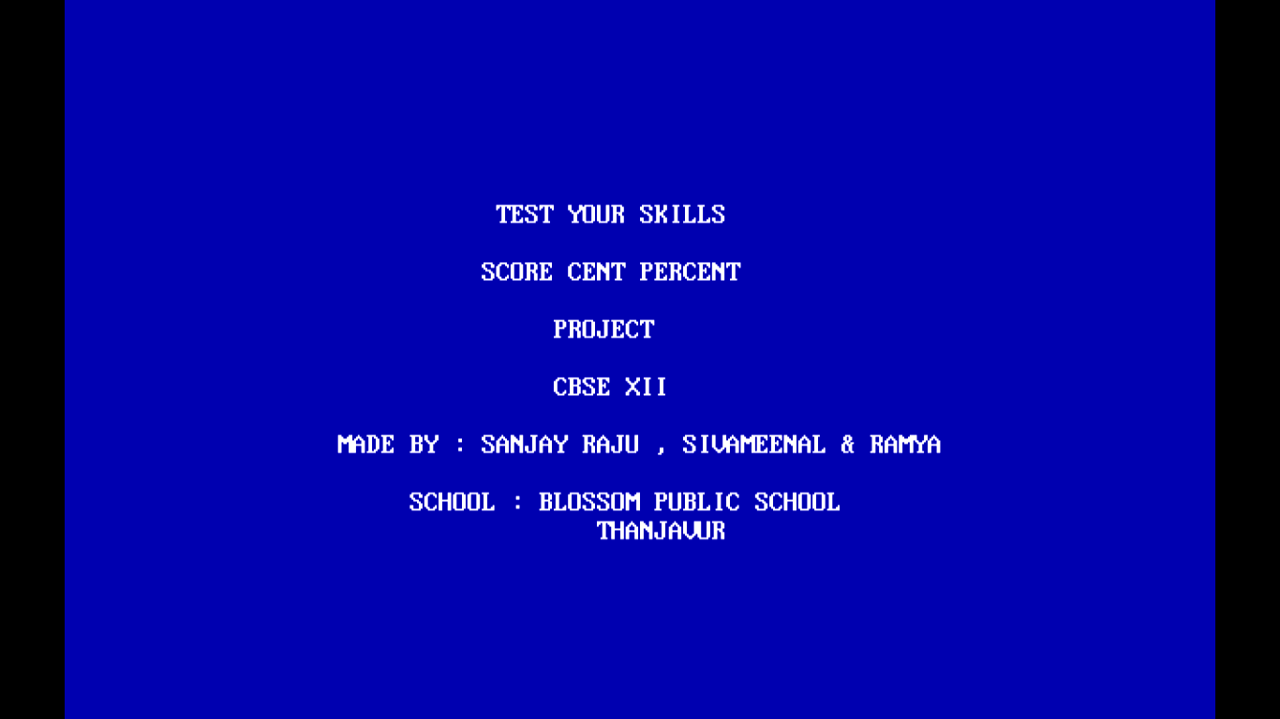

Main menu screen

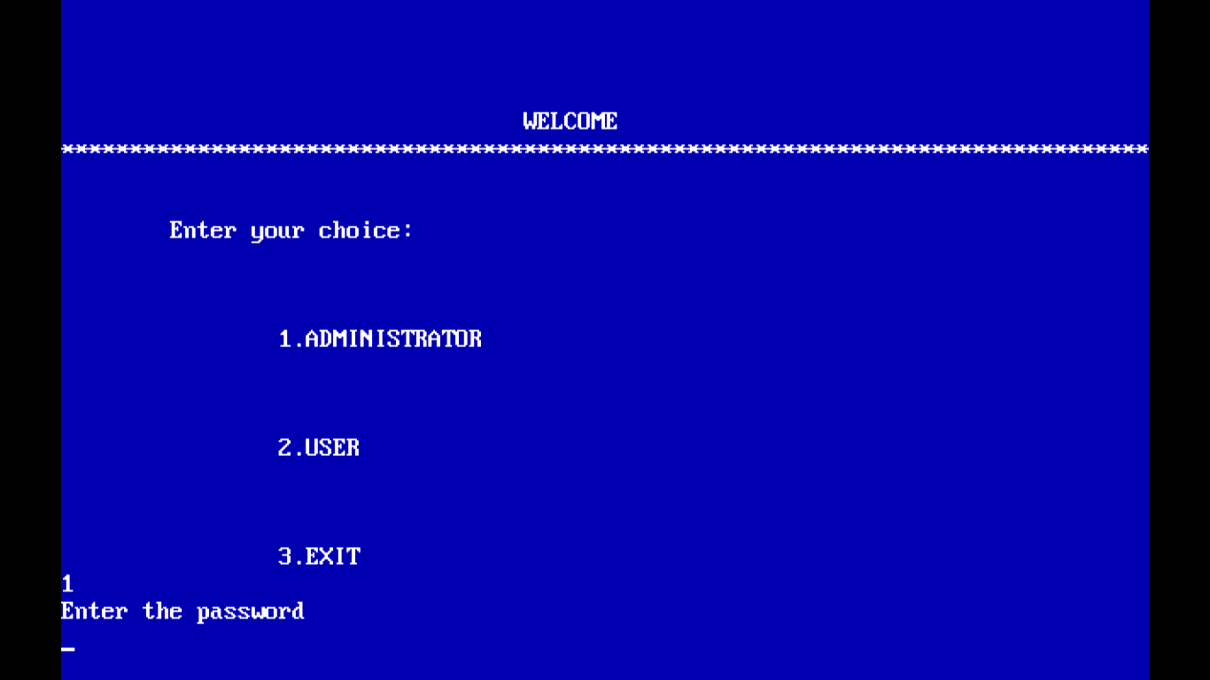

Administrator menu

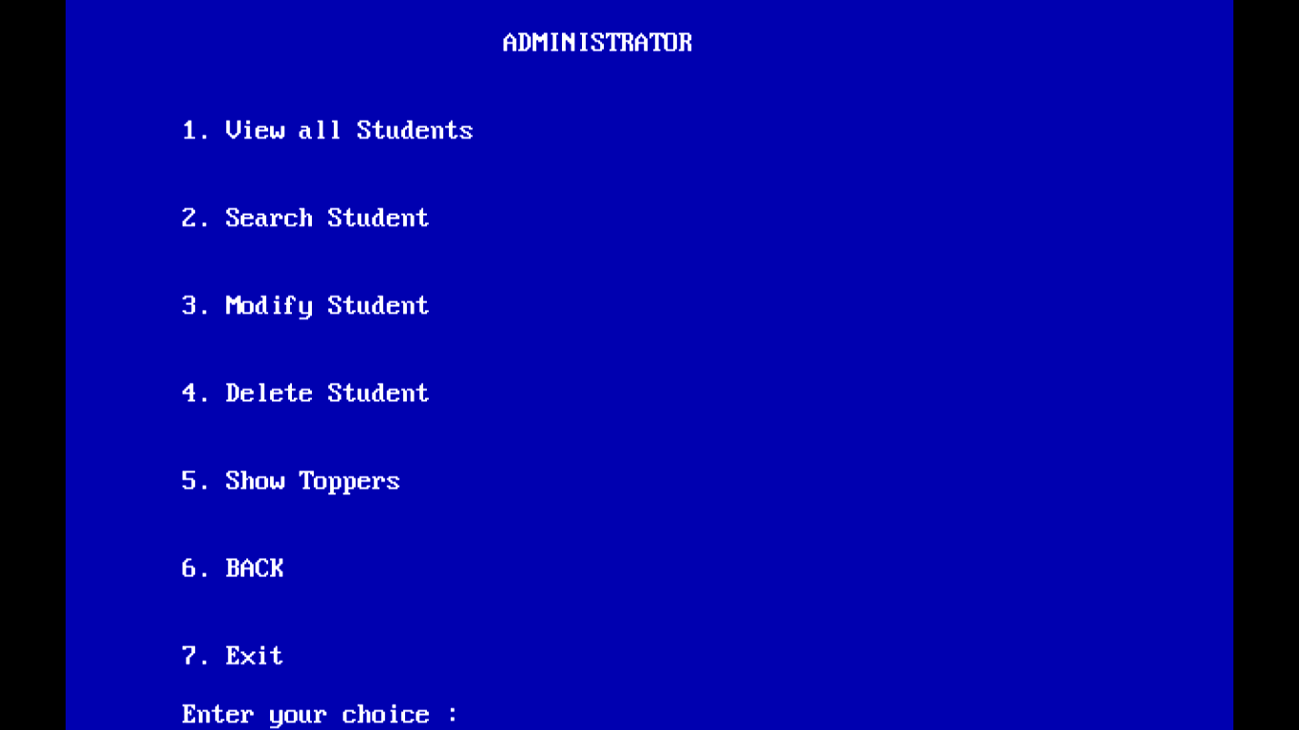

User menu

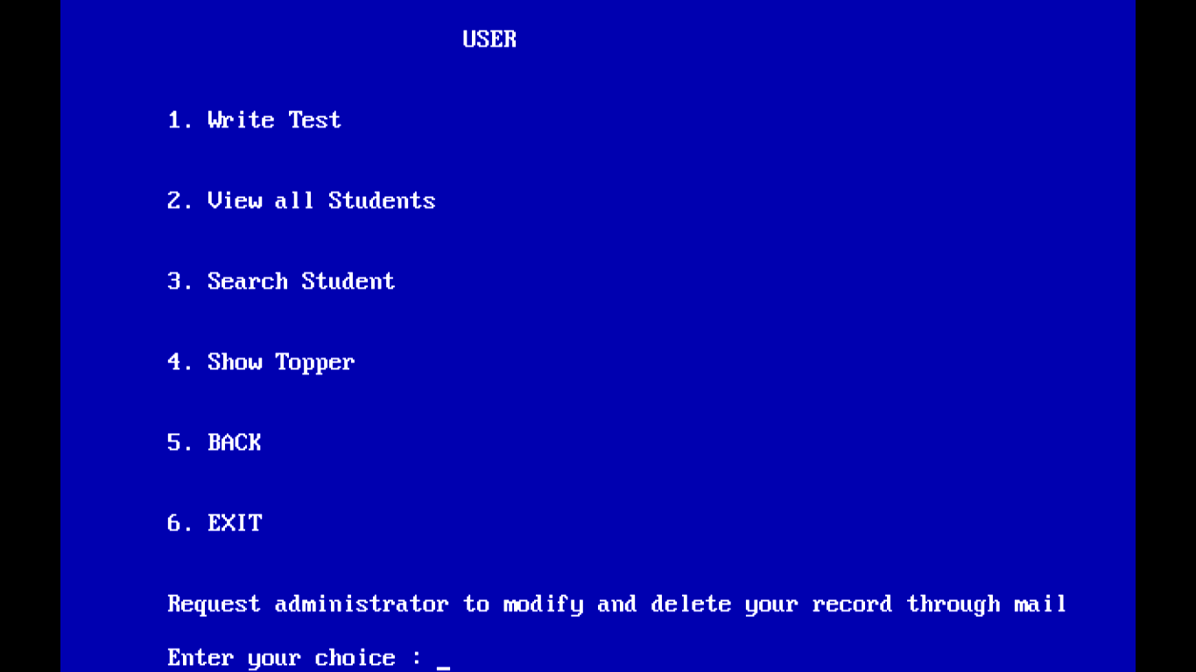

Write test

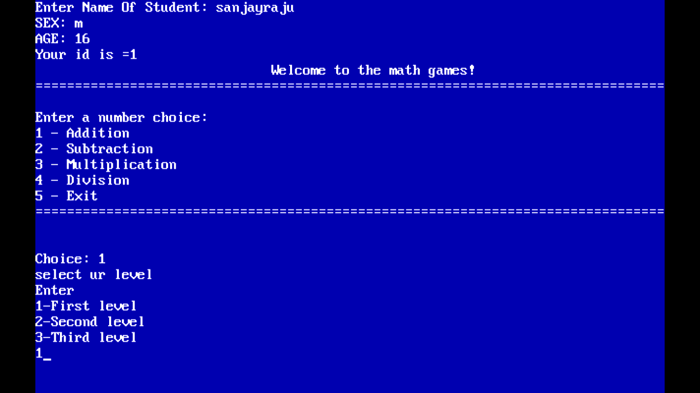

Level 1 test

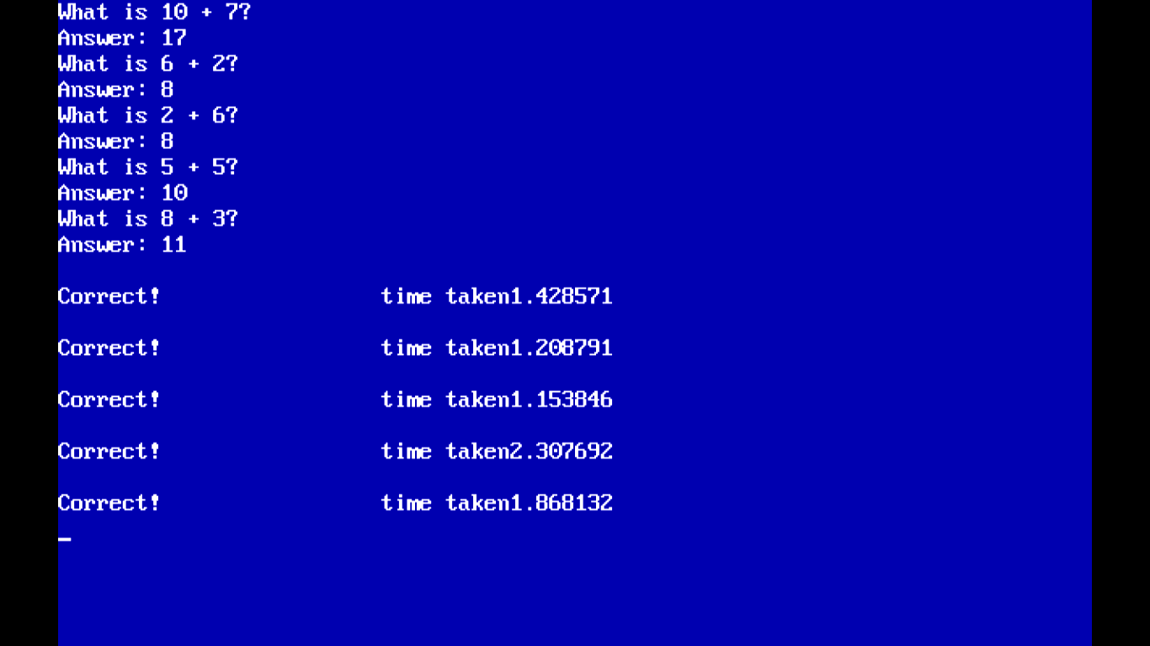

Result

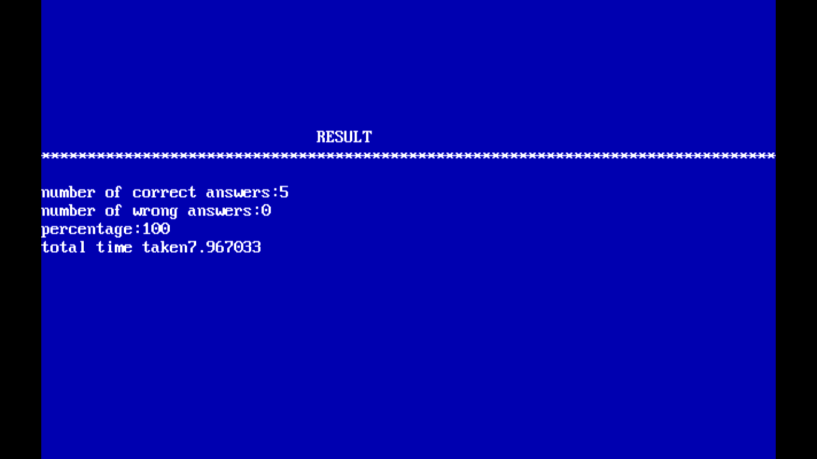

View all students

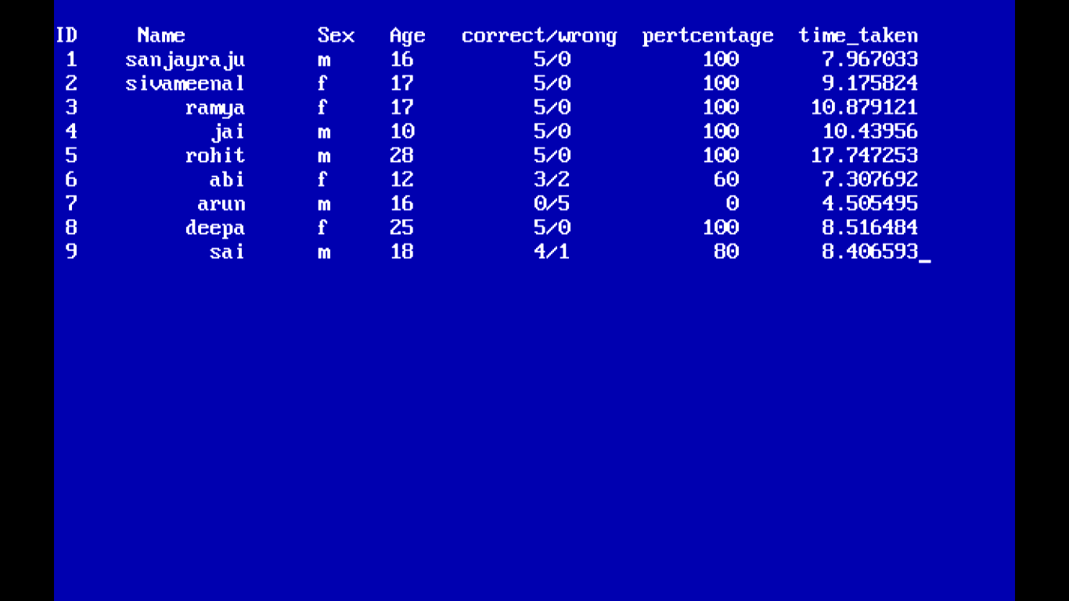

Show toppers

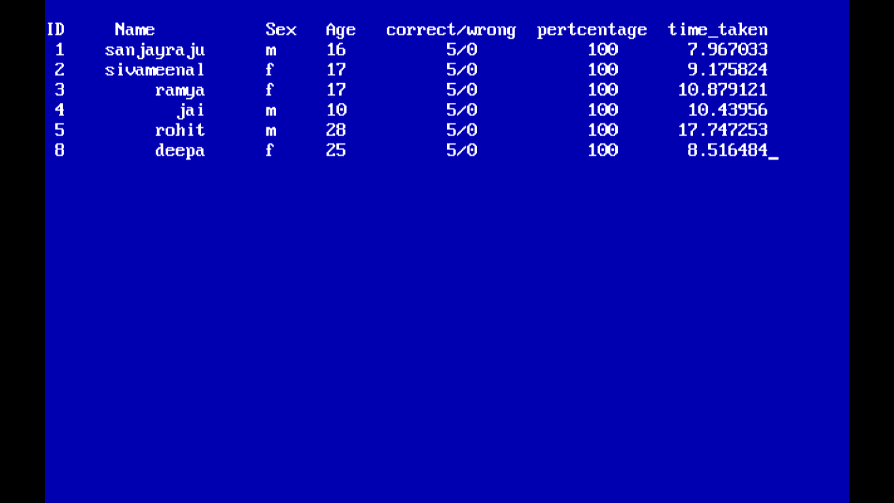

Search student

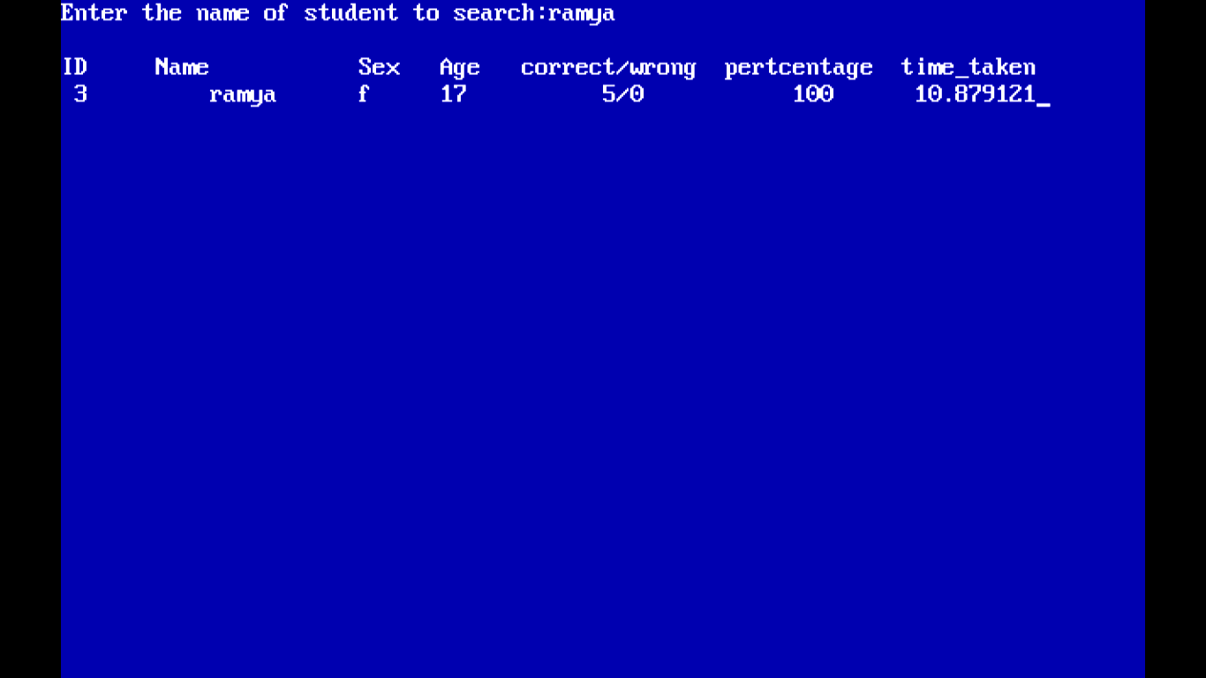

Delete student

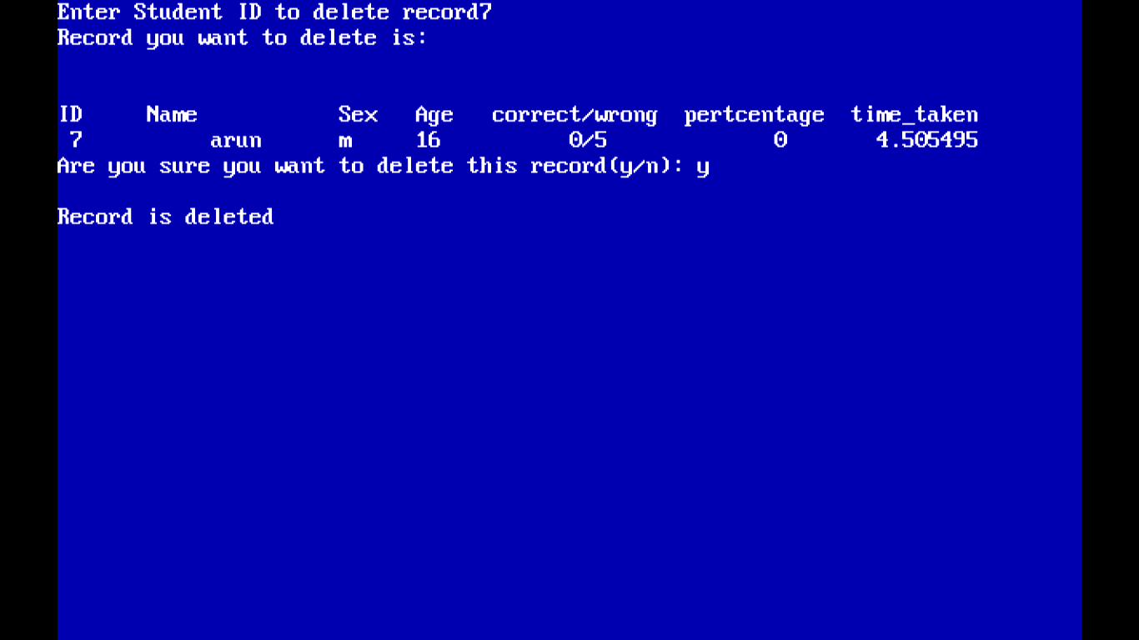

View all students after delete

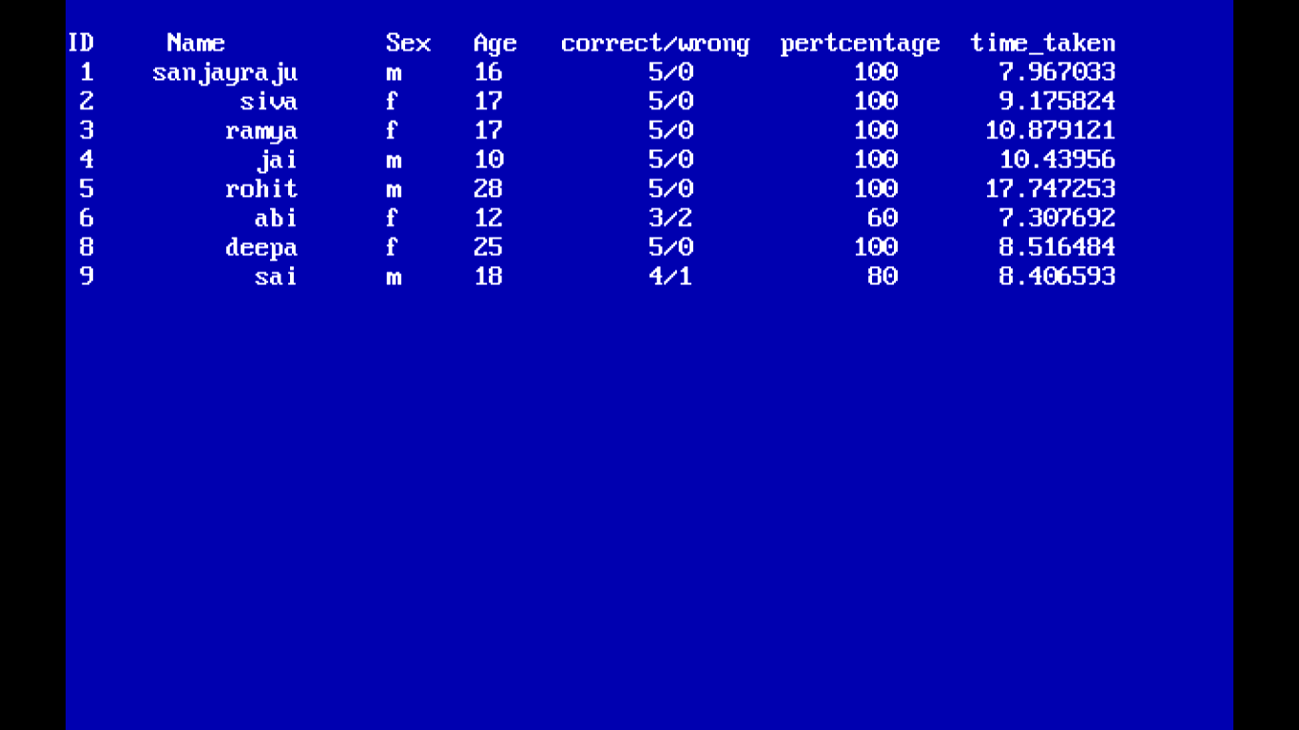

View all students

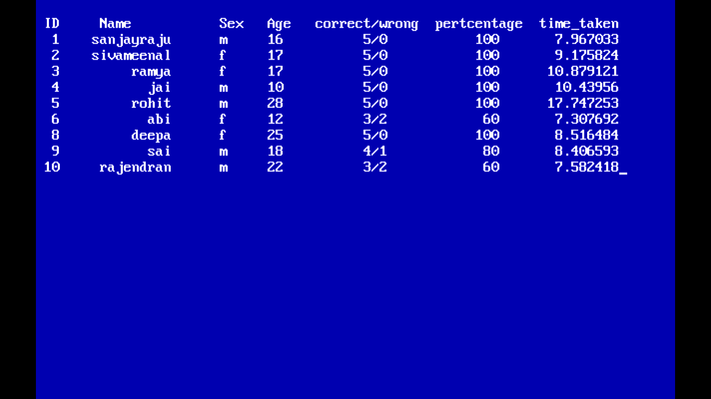

Modify student

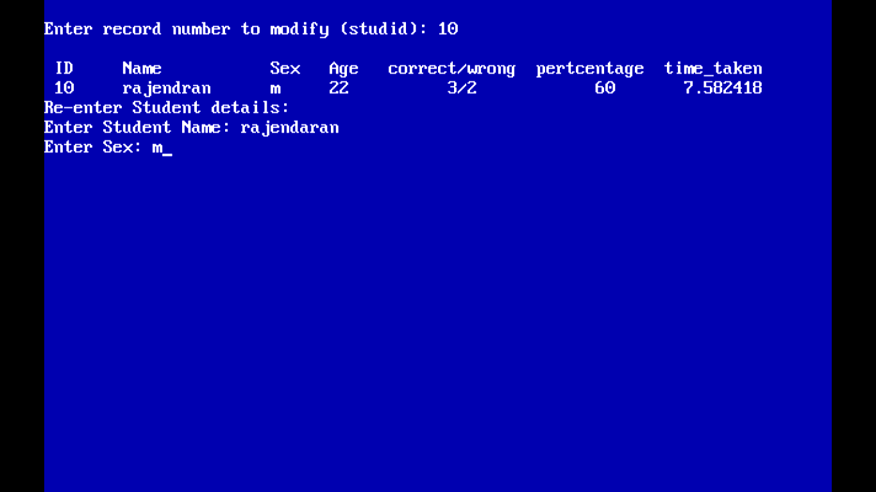

View all student after modifying

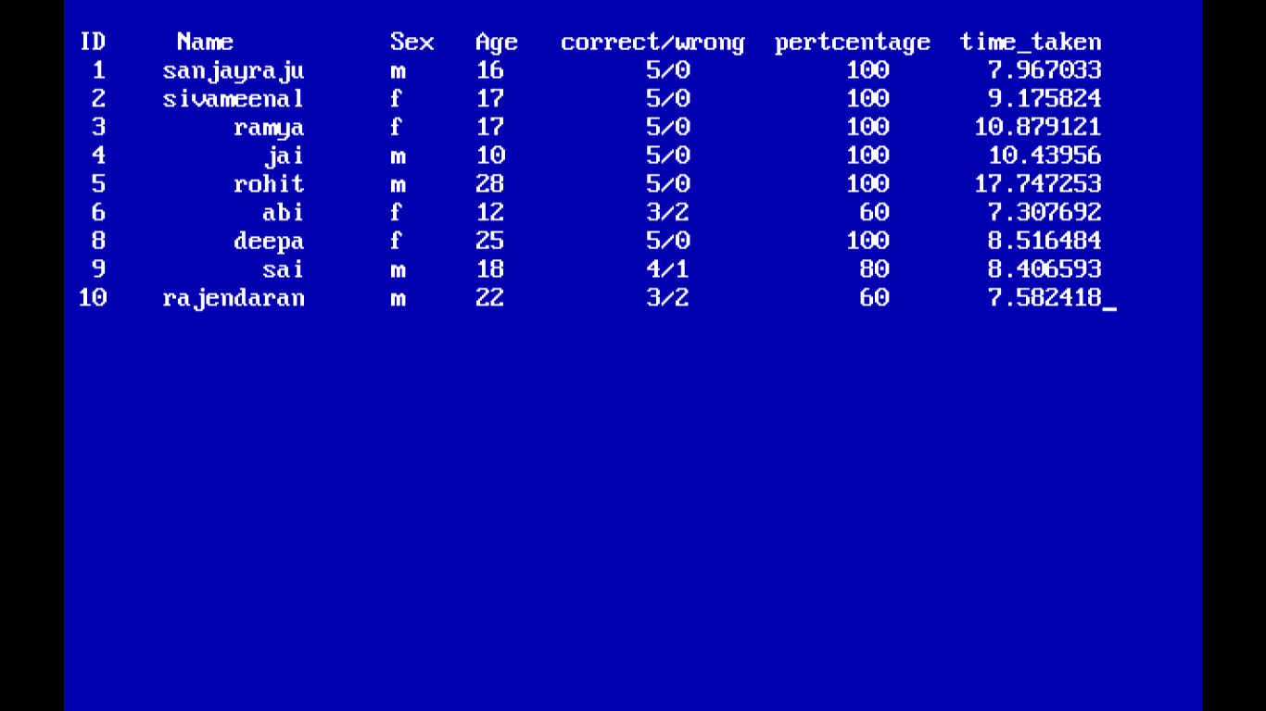

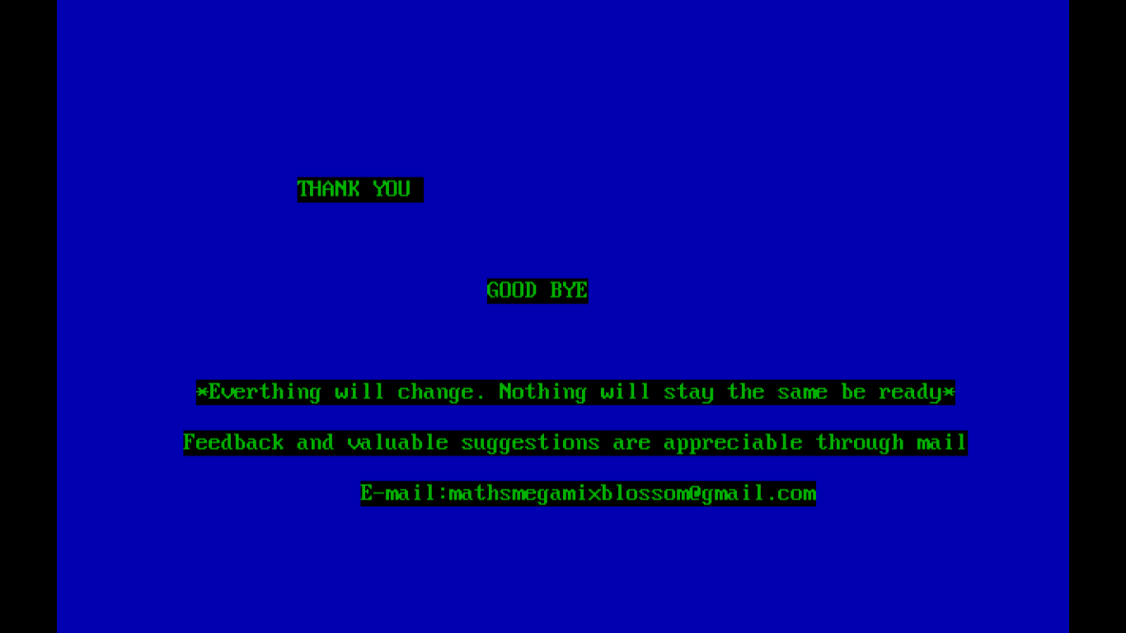

CONCLUSION

**The aim of carrying out this project work are:**

* + To apply and adapt a variety of problem solving strategies to solve problem.
  + To improve thinking skills.
  + To promote effective mathematical communication to develop mathematical knowledge through problem solving in a way that increase student’s interest and confidence.
  + To use the language of mathematics to express mathematical ideas precisiely.
  + To provide learning environment that stimulates and enhances effective learning.
  + To develop positive attitude towards mathematics



**BIBLIOGRAPHY**

BIBLIOGRAPHY
1 http://www.google.com/
2 http://en.wikipedia.org
3 Computer Science with C++ by Sumita
Arora
4 Object Orien...